**ATTACHMENT A**

**Accountable Authority (Chief Executive) Certification for Government Advertising Campaign**

**Certification Statement – Play the Aussie Way campaign**

I certify that the Play the Aussie Way campaign complies with the Australian Government Guidelines on Information and Advertising Campaigns by non-corporate Commonwealth entities (Guidelines).

This certification takes into consideration the Report of the Independent Communications Committee. It also takes into consideration advice and evidence provided by officials within Sport Integrity Australia with responsibility for the design, development and implementation of the Play the Aussie Way campaign.

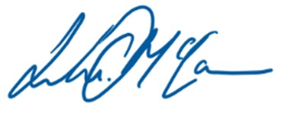

**Luke McCann**

Acting Chief Executive Officer

Sport Integrity Australia

05 December 2023